Impact of Denoising on Classification Performance of Retinal Diseases
A thesis paper submitted in partial fulfillment of the requirements for the degree of
B.Sc. (Engineering) in Electrical and Electronic Engineering

Course Title: Project/Thesis
Course Code: EEE 400

Submitted by
Student ID: 1502216 Student ID: 1602266 Student ID: 1602273

Approved as to style and content by

……………………………………… ………………………………………
Supervisor Co-Supervisor


Hajee Mohammad Danesh Science and Technology University,
Dinajpur-5200

This is to certify that this thesis is prepared by Student ID: 1502216, 1602266, 1602273 and complies with the regulations of this university and meets the accepted standards with respect to originality and quality.
Signed by the final examining committee:

…………………………………………………………………………………...
Chairman

…………………………………………………………………………………...
External

………………………………………………………………………………….
Internal

…………………………………………………………………………………...
Supervisor

…………………………………………………………………………………...
Co-Supervisor
DECLARATION

This is to certify that the thesis work entitled “Impact of Denoising Retinal OCT images in Classification” carried out by the student ID: 1502216, 1602266, 1602273, under our supervisor as a requirement for the award of Bachelor of Science in Electrical and Electronic Engineering.

DEDICATED TO
OUR BELOVED PARENTS AND RESPECTABLE TEACHERS

Acknowledgments

We would like to thank everyone who has helped and supported us during our graduate study. Their direct and indirect contributions to this dissertation are highly appreciated. At the very first we thank the almighty Allah for giving us the opportunity and ability to complete this thesis.
Then we are honored to express our deepest and sincerest gratitude to our parents who supported us all the time and helped us all the way they could to continue our work.
Then we express our sincerest gratitude to our supervisor Md. Ferdous Wahid, Assistant Professor, Department of Electrical & Electronic Engineering and Co-supervisor Md. Safiqul Islam, Assistant Professor, Department of Electrical & Electronic Engineering, for their continuous support during our Thesis work. Their patience, motivation, enthusiasm and immense knowledge have helped us to make our work successful and so we are extremely grateful to them. Anytime when we had difficulties in our research, they were always there to help with their intelligence, diligence and patience.
We also thank Specially to Md. Faruk Kibria, Assistant professor and chairman, Department of Electrical & Electronic Engineering, for his wise supervision, proper guidance and continuous support that encouraged us to go on with our work.
Finally, we also thank our group members and friends for their dedication and hard-work to complete the thesis.

Abstract

In this paper the main motive is to coming up with the impact of denoising Optical Coherence Tomography (OCT) Retinal images via showing accuracy rate difference between classification with noisy images and denoised images. Retinal OCT images are always noisy. Even in better cases, it’s hard to find a single image without any noise. Image classification is used for classify among different types of that same category. Block Matching 3D (BM3D) is the denoising algorithm which will be used for preparing denoised dataset with the help of Sk-image (scikit-image) and OpenCV. For classification, Convolutional Neural Networks (CNN), specifically Inception V3 network is used on the both data sets (Noisy Images Data set and Denoised Image Data set) with Python and the Keras deep learning library. In data sets, they are prepared with Drusen and Normal Images. Applying classification models over those data sets, a clear concept will come out as the impact of denoising retinal OCT images in classification.

Key-words: Speckle noise, Optical Coherence Tomography (OCT), Block Matching 3D (BM3D), Scikit-image, OpenCV, Convolutional Neural Networks (CNN), Inception V3, Keras, Python, Druse

List of Contents
Page No
Dedication …………………………………………………………… 3
Acknowledgments …………………………………………………………. 4
Abstract ……………………………………………………………………. 5
List of figures ……………………………………………………………….. 8
List of Table ………………………………………………………………… 9
Chapter 1
Introduction ………………………………………………………………….. 10
Chapter 2
Literature Review ……………………………………………………………. 16
Chapter 3
Data set Preparation …………………………………………………………. 18
Chapter 4
Methodology ………………………………………………………………… 21
4.1 Noise in OCT image ……………………………………………… 21
4.2 Image denoising with Block Matching 3D ……………………….. 22
4.3 Classification with Inception V3 Convolutional Network ……….. 23
Chapter 5
Experimental Setup ………………………………………………………….. 26
5.1 Hardware Requirement ………………………………………….. 26
5.2 Software Requirement …………………………………………... 27
Chapter 6
Result and Discussion ……………………………………………………….. 29
6.1 Performance Evaluation ………………………………………… 29
6.2 Comparative Study ……………………………………………… 34
Chapter 7
Conclusion ………………………………………………………………….. 35
References …………………………………………………………………... 36

List of Figure
No Table Name Page No
01 Different Layers of Retinal OCT Images 13
02 Drusen OCT Image 16
03 Noisy Dataset before and after of splitting for training and testing 20
04 Original Image VS Filtered Image with BM3D 21
05 Denoised Dataset before and after of splitting for training and testing 22
06 Scheme of the BM3D algorithm. 24
07 Inception V3 architecture 25
08 Inception V3 Transfer Learning Model 26
09 OCT Machine 28
10 Anaconda Environment 30
11 Accuracy of classification with noisy image dataset 31
12 Training and validation accuracy curve on the basis of number of epochs 32
13 Model accuracy and model loss curve 32
14 Confusion Matrix for noisy image dataset classification 33
15 Accuracy of classification with denoised image dataset 33
16 Training and validation accuracy curve on the basis of number of epochs 34
17 Model accuracy and model loss curve 34
18 Confusion Matrix for noisy image dataset classification 35

List of Table

No Table Name Page No

- Comparison of classification results between Noisy Image 35
Dataset and Denoised Image Dataset

Chapter1
Introduction

Optical coherence tomography (OCT) is a recently established imaging technique to describe different information about the internal structures of an object and to image various aspects of biological tissues, such as structural information, blood flow, elastic parameters, change of polarization states, and molecular content. In contrast to OCT technology development which has been a field of active research since 1991, OCT image segmentation has only been more fully explored during the last decade. [22] [23] Segmentation, however, remains one of the most difficult and at the same time most commonly required steps in OCT image analysis. No typical segmentation method exists that can be expected to work equally well for all tasks.
One of the most challenging problems in OCT image segmentation is designing a system to work properly in clinical applications. There is no doubt that algorithms and research projects work on a limited number of images with some determinate abnormalities (or even on normal subjects) and such limitations make them more appropriate for bench and not for the bedside. Moreover, OCT images are inherently noisy, thus often requiring the utilization of 3D contextual information. Furthermore, the structure of the retina can drastically change during disease. Nevertheless, OCT image denoising is a rapidly growing and important area and a great deal of efforts went into designing algorithms for automatic noise reduction of retinal OCTs.
Covering the inside of most of the eye, the retina is a multilayered structure responsible for transforming light energy into neural signals for further use by the brain. In very general terms, the processing of light starts with the light sensitive photoreceptor cells (rods and cones), which are actually located in the outer portion of the retina (away from the incoming light). These cells convert the light signal into action potentials that are transmitted by the bipolar neurons in the central layers of the retina to the ganglion cells of the inner retina. [25] It is the axons of the ganglion cells that eventually exit the eye to form the optic nerve. Other cells in the retina, such as horizontal cells, amacrine cells and inter plexiform neurons, also help in the processing of the neural signal at a local level. [24] Neuroglial cells (such as Muller cells) provide structure and support. Based on its appearance from light microscopy, the retina is traditionally considered to be composed of the following ten major “layers” (starting with the outermost layer). [27]
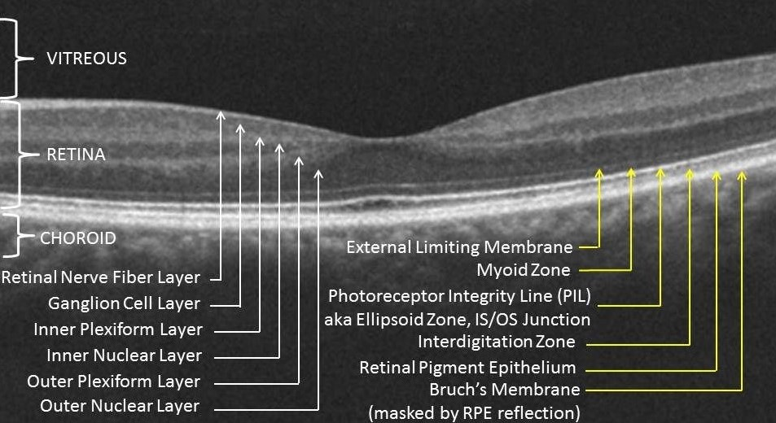

Figure 1: Different Layers of Retinal OCT Images

Reginal pigment epithelium (RPE): single layer of pigmented hexagonal cells
Photoreceptor layer: the outer (containing the light-sensitive discs) and inner segments of rods and cones
External (or outer) limiting membrane (ELM or OLM): intercellular junctions between photoreceptor cells and between photoreceptor and Muller cells (not an actual membrane)
Outer nuclear layer (ONL): rod and cone cell bodies
Outer plexiform layer (OPL): synapses between photoreceptor cells and cells from the inner nuclear layer
Inner nuclear layer (INL): cell bodies of bipolar cells, horizontal cells, amacrine cells, inter plexiform neurons, Muller cells, and some displaced ganglion cells
Inner plexiform layer (IPL): synaptic connections between bipolar cell axons and ganglion cell dendrites
Ganglion cell layer (GCL): mostly ganglion cell bodies
Nerve fiber layer (NFL): ganglion cell axons
Internal limiting membrane (ILM): innermost membrane of retina separating the retina from the vitreous.
These show that Retinal OCT Images have a lot of information in it to deal with. But the biggest problem that arises is the noises. There are many kinds of noises arrive in dealing with these types of images. Such as- Amplifier Noise (Gaussian Noise), Salt-and-pepper noise, Poisson noise, Speckle noise. But for OCT images, speckle noise is our main focus. [26] [28]
For examining the OCT images, we’ll reduce the speckle noises of those. There are many methods those are already applied but we’ll use Python as our main tool. Two very popular and efficient libraries of Python are OpenCV (CV stands for Computer Vision) and Sk-image (Scikit image). OpenCV is a cross-platform library using which we can develop real-time computer vision applications. It mainly focuses on image processing, video capture and analysis including features like face detection and object detection and scikit-image is an open-source image processing library for the Python programming language. [29] It includes algorithms for segmentation, geometric transformations, color space manipulation, analysis, filtering, morphology, feature detection, and more.
Now-a-days optical coherence tomography (OCT) imaging is a very important well-established clinical tool for assessing optic nerve head (ONH) tissues, and for monitoring many ocular and neuro-ocular pathologies. Because of speckle noise of limited bandwidth, the visualization quality of an OCT image is often degraded. [1] The image contrast deteriorates by the granular pattern of speckle noise and it is quite difficult to resolve small and low-intensity structure. These affects the clinical interpretation of OCT data. Again, the poor images have automated segmentation errors. To improve denoising OCT scans, there are many hardware and software scheme. Hardware is needed to robust noise suppression through frequency compounding and multi-frame averaging (spatial compounding). On the other hand, software is needed to denoise through numerical algorithms or filtering techniques. This deep learning is applied in the medical imaging field such as magnetic resonance imaging (MRI). [2] Single-frame denoising and multi-frame denoising are the two categories of denoising method according to the number of frames. Both of these techniques, multi-frame denoising is commonly used method. To improve the signal-to-noise ratio (SNR), the average of all uncorrelated frame is needed. But this technique needs hardware modification and complicated acquisition processes. Single-frame methods are divided into two groups:
Image-domain methods and wavelet-domain methods. Image-domain methods often adopt regularizes from the field of image processing, e.g., TV regularization needs a Gamma distribution for the speckle [32]. Wavelet-based methods exploit basic properties of wavelet coefficients of OCT images. TO develop the quality of OCT images, Gaussian Scale Mixtures with Bayesian least square estimation, interval type II fuzzy based thresholding filtering, block-matching 3D (BM3D) based technique in the logarithm space are used. Among all the techniques block-matching 3D (BM3D) gives the best result [3]. To denoise a noisy picture we need scikit-images, total variation, bilateral, and wavelet denoising filters. The collection of algorithms for OCT image processing are known as scikit-image. This is used because there is no restriction to use it and it is free. To denoise a noisy version of OCT image we may use total variation, bilateral, and wavelet denoising filters. “Posturized” images with flat domains separated by sharp edges are produced but total variation and bilateral algorithms. The degree of posterization can be changed by controlling the tradeoff between denoising and faithfulness to the original image. For features learning, features extraction and dimensions reduction, deep network like autoencoder and Convolutional Neural Networks (CNN) is most popular. In BM3D technique, OpenCV-Python which is library of python is used for numerical operations with a MATLAB-style syntax.
For image recognition, Inception v3 is commonly used model which shows greater than 78.1% accuracy. Among other convolutional classification networks, Inception V3 is far more popular. That’s why we’ve used this network for performing the classification portion. [4] [5]
In the classification portion we’ll use Drusen Images and Normal Images. Drusen are small yellow deposits of fatty proteins (lipids) that accumulate under the retina.
The retina is a thin layer of tissue that lines the back of the inside of the eye, near the optic nerve. The optic nerve connects the eye to the brain. The retina contains light-sensing cells that are essential for vision.
Drusen are like tiny pebbles of debris that build up over time. There are two different types of drusen: soft and hard.
- “soft” drusen are large and cluster closer together
- “hard” drusen are smaller and more spread out
Having a few hard drusen is normal as you age. Most adults have at least one hard drusen. This type of drusen typically does not cause any problems and doesn’t require treatment.
Soft drusen, on the other hand, are associated with another common eye condition called age-related macular degeneration (AMD). It’s called “age-related” macular degeneration because it’s more common in people older than 60. As soft drusen get larger, they can cause bleeding and scarring in the cells of the macula. Over time, AMD can result in central vision loss. In other words, the condition can affect what you’re able to see when you’re looking straight ahead.
Drusen can also occur in the optic nerve. Unlike drusen in the retina, optic nerve drusen can cause minor loss of peripheral (side) vision. Optic nerve drusen are not related to aging. They’re more commonly seen in children.

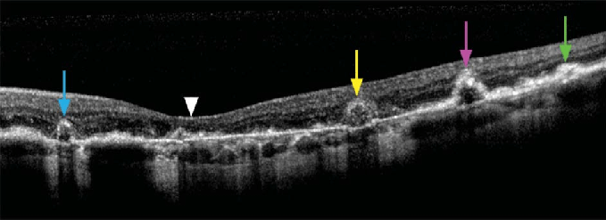
Figure 2: Drusen OCT Image

Drusen don’t usually cause any symptoms. Most people don’t know they have drusen until they’re discovered by an eye doctor (ophthalmologist or optometrist) during a routine eye exam.
Drusen can be seen during a dilated eye exam using an ophthalmoscope, a device that allows the doctor to see the retina and back of the eye.
If your eye doctor detects many soft drusen on an eye exam, they’ll likely want to run additional tests for age-related macular degeneration. The ophthalmologist may also ask you questions about any other symptoms you might be experiencing.
Symptoms of AMD include:
- distortion of straight lines in your field of vision
- difficulty adapting from bright lights to low lights
- hazy or blurry vision
- blank spot in your central vision
Some people with optic nerve drusen might experience loss of peripheral vision and occasional flickering or graying of vision.

Chapter 2
Literature Review

Recent research has focused on automatically classifying OCT images by extracting image attributes and using classification or segmentation algorithms. A research proposed a system for diagnosing diabetic retinopathy using 350 fundus images. [6] The images used were obtained from Aravind Eye Hospital and Graduate School of Ophthalmology. The image is obtained in RBG from the fundus camera. The author first preprocesses the image to suit machine learning, then converts the image to a grayscale image, and then applies adaptive histogram equalization to improve the contrast of the image. [7] In order to reduce image noise and size, Discrete Wavelength Transformation (DWT) is applied. The author uses image segmentation to extract image features for research purposes, such as blood vessels, NPDR bleeding, and PDR exudate. [8]Three classifiers are used: Probabilistic Neural Network (PNN), Bayes Classifier and Support Vector Classifier (SVM). For the SVM classifier, the best scores for specificity, sensitivity, and accuracy are 96, 98, and 97.6, respectively. 28.6% of the data set is used as the training set, and the remaining 72.4% is used for training. Training with more data can improve performance. Mahendran Gandhi et al. Use the Gray Level Coexistence Matrix (GLCM) to extract the input attributes used in the SVM classifier. [9] They tried to use morphological operators and SVM classifiers to develop an automatic method to detect exudate on color images of unstretched retinal fundus. We used 5 fundus images of 2196×1958 pixels in JPEG format. The SVM classifier is used to assess the severity of the disease, regardless of whether the patient's eye exposure is moderate or severe. As a result of the classifier used, an abnormality was diagnosed on five images, while exudate was moderately expressed in three images and two. [10] Sohini Roy Chowdhury et al. proposed a computerized screening system called DREAM. DREAM uses fundus images collected from two databases (DIARETDB1 data set and MESSIDOR data set) to distinguish the DR image from the normal image and generate the severity. AdaBoost, Support Vector Machine (SVM), Gaussian Mixture Model (GMM) and k Neural Neighbors (kNN). AdaBoost helps reduce the number of extracted functions from 78 selected functions to 30. Through the reduction function, the average calculation time is reduced from 59.54 seconds to 3 seconds. The sensitivity, specificity and AUC of the 46 s DREAM system reached 100%, 53.1% and 0.904, respectively. Ahmed El Tanboli et al. [11] developed a DR detection system that uses three-stage OCT images and uses various segmentation and classification techniques. They extracted three main features from the segmented OCT image to quantify the following:
"reflectivity", "curvature" and "thickness" of the retinal layer. The feature of the segmented layer is a function that describes the random distribution of the extracted features, which is called the cumulative probability distribution function (CDF). The classifier used is trained to select the characteristics of the retinal layer and use its CDF to identify DR. The sensitivity, accuracy and specificity of the system are 83%, 92% and 100%, respectively. Mohammed Ghazal et al. It is recommended to use OCT imaging technology to detect the CADe system of NPDR early. The designed system includes four main stages: preprocessing, feature extraction, system training, diagnosis and testing. The preprocessing step involves segmenting the OCT image of the retina into 12 extracted slices and aligning them using the outer core layer number 6 ONL as a reference. [12] The output of the preprocessing step is forwarded to the Convolutional Neural Network (CNN) for training and evaluation. [13] The proposal has achieved the best results. The sensitivity, specificity and accuracy of CNN are 100%, 88% and 94%, respectively. The accuracy of the y alignment and how it affects the final result is not disclosed. Peyman Gholami et al. proposed an automatic classification method based on OCT image processing to identify eyes with eye diseases such as RD, age- related macular degeneration (AMD) or macular hole (MH) or normal eyes. These images were collected at Sankara Nethralaya Eye Hospital (SN) in Chennai, India. Use wavelet-based noise removal technology to preprocess the image through noise removal. In addition, the image is reduced to 500×750 pixels. Extract LBP attributes to power the classifier used. [14] The selection of functions used reduced the number of functions used from 375,000 to 16,383.

Chapter 3
Data-set Preparation
For determining the impact of denoising OCT images in classification we need to prepare two different datasets. One is with noisy images and the other one is with denoised images. They will be prepared based on two categories of images. They are – Drusen and Normal Category. The preparation process is below:
Noisy Image Dataset:
A noisy image dataset is prepared with 2100 images of Drusen and Normal Category. They images were collected from Kaggle. After downloading the dataset from Kaggle, we prepared a new data set from those images. We didn’t take those images randomly. The quality, shape and size were considered as the basic requirements for selected those images.
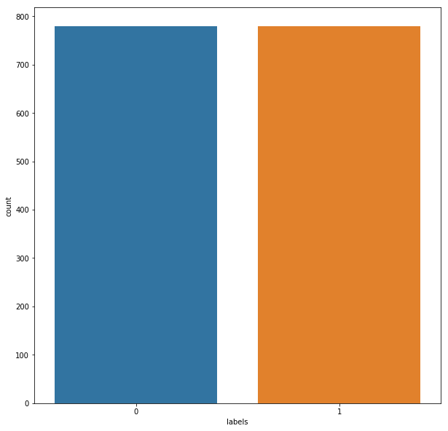
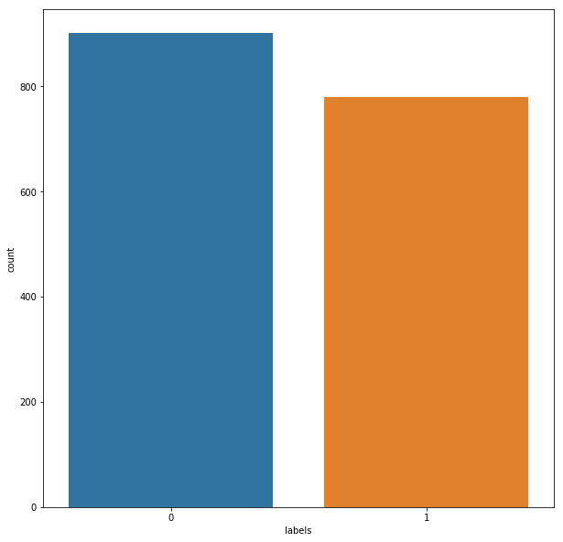
Then finally we got our dataset of 2100 images.

Figure 3: Noisy Dataset before and after of splitting for training and testing

Denoised Image Dataset:
This dataset is prepared with the same images which were used for the noisy image dataset. For denoising the images there are several denoising algorithms. Like- Gaussian Filter, Non-Local Means filter, Anisotropic Diffusion Filter etc. [30] [31] [32] But we’ve chosen Block Matching 3D AKA, BM3D filter for denoising the noisy images. Among the other denoising algorithms, BM3D shows the most details than the others that’s why we choose that.
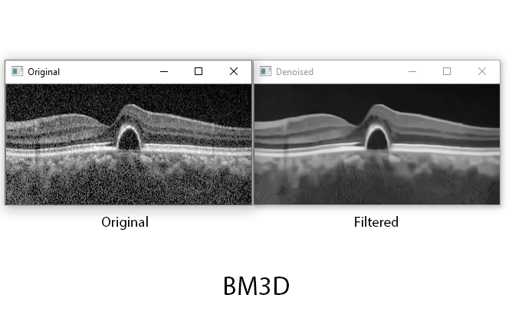

Figure 4: Original Image VS Filtered Image with BM3D

We put the whole noisy image dataset into the BM3D filter and got a same 2100 images dataset but these are denoised.

Figure 5: Denoised Dataset before and after of splitting for training and testing

Chapter 4
Methodology

4.1 Noise in Optical Coherence Tomography Images:

Amplifier noise (Gaussian noise):
The standard model of amplifier noise is additive, Gaussian, independent at each pixel and independent of the signal intensity. In color cameras where more amplification is used in the blue color channel than in the green or red channel, there can be more noise in the blue channel. Amplifier noise is a major part of the "read noise" of an image sensor, that is, of the constant noise level in dark areas of the image.
Salt-and-pepper noise:
An image containing salt-and-pepper noise will have dark pixels in bright regions and bright pixels in dark regions. This type of noise can be caused by dead pixels, analog-to-digital converter errors, bit errors in transmission, etc. This can be eliminated in large part by using dark frame subtraction and by interpolating around dark/bright pixels.
Poisson noise:
Poisson noise or shot noise is a type of electronic noise that occurs when the finite number of particles that carry energy, such as electrons in an electronic circuit or photons in an optical device, is small enough to give rise to detectable statistical fluctuations in a measurement.
Speckle noise:
Speckle noise is a granular noise that inherently exists in and degrades the quality of the active radar and synthetic aperture radar (SAR) images. [34] Speckle noise in conventional radar results from random fluctuations in the return signal from an object that is no bigger than a single image-processing element. It increases the mean grey level of a local area. Speckle noise in SAR is generally more serious, causing difficulties for image interpretation. It is caused by coherent processing of backscattered signals from multiple distributed targets. [33] In SAR oceanography, for example, speckle noise is caused by signals from elementary scatters, the gravity-capillary ripples, and manifests as a pedestal image, beneath the image of the sea waves.

4.2 Image Denoising with Block Matching 3D Filter
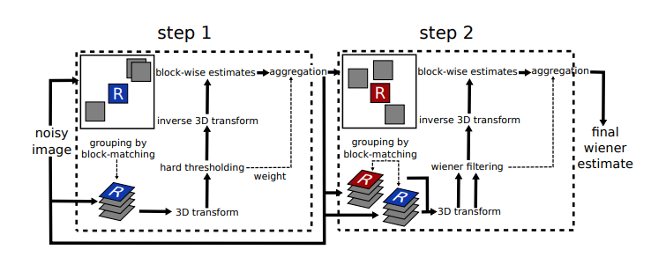
Block-matching and 3D filtering (BM3D) is a 3-D block-matching algorithm used primarily for noise reduction in images. It is an algorithm for attenuation of additive spatially correlated stationary (aka colored) Gaussian noise. This package provides a wrapper for the BM3D binaries for use for grayscale, color and other multichannel images for denoising and deblurring. Collaborative filtering is a special procedure developed to deal with these 3D groups. We realize it using the three successive steps: 3D transformation of 3D group, shrinkage of transform spectrum, and inverse 3D transformation. The result is a 3D estimate that consists of the jointly filtered grouped image blocks. By attenuating the noise, the collaborative filtering reveals even the finest details shared by grouped blocks and at the same time it preserves the essential unique features of each individual block. The filtered blocks are then returned to their original positions.

Figure 6: Scheme of the BM3D algorithm.
For performing the algorithm, we are going to use OpenCV library from Python as our primary tool. On the other hand, BM3D is also a library of python. After importing those, we need to set a parameter of that library to perform the task.
Those are: sigma_psd and stage_arg.
where for our noisy image, we’ve used
sigma_psd=30/255,
stage_arg=bm3d.BM3DStages.HARD_THRESHOLDING

4.3 Classification with Inception V3 Convolutional Network
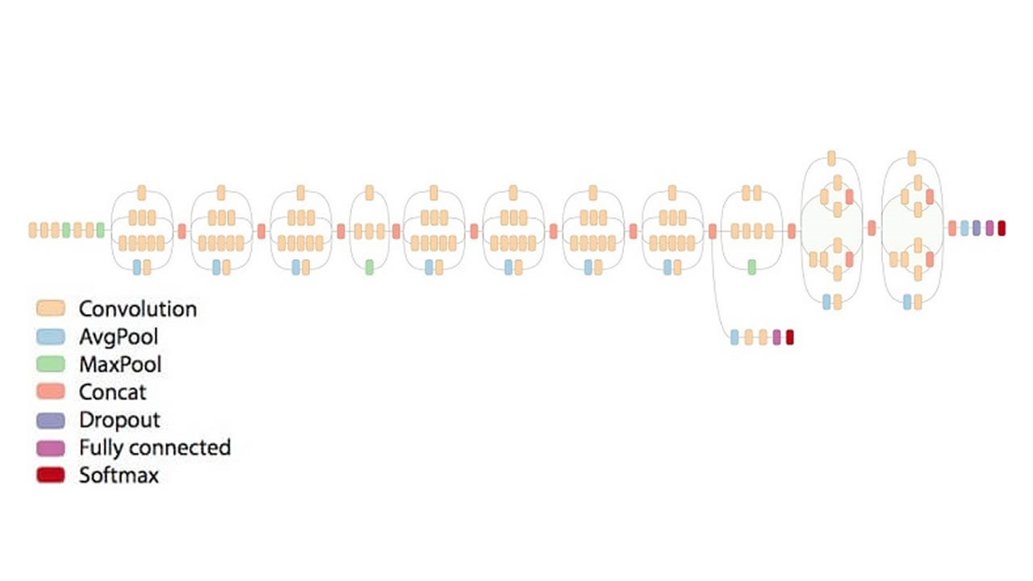
Inception V3 by Google is the 3rd version in a series of Deep Learning Convolutional Architectures. Inception V3 was trained using a dataset of 1,000 classes (See the list of classes here) from the original ImageNet dataset which was trained with over 1 million training images, the Tensorflow version has 1,001 classes which is due to an additional "background' class not used in the original ImageNet. Inception V3 was trained for the ImageNet Large Visual Recognition Challenge where it was a first runner up. [15] [19]

Figure 7: Inception V3 architecture

Convolutional neural networks are a type of deep learning neural network. These types of neural nets are widely used in computer vision and have pushed the capabilities of computer vision over the last few years, performing exceptionally better than older, more traditional neural networks; however, studies show that there are trade-offs related to training times and accuracy. [16]
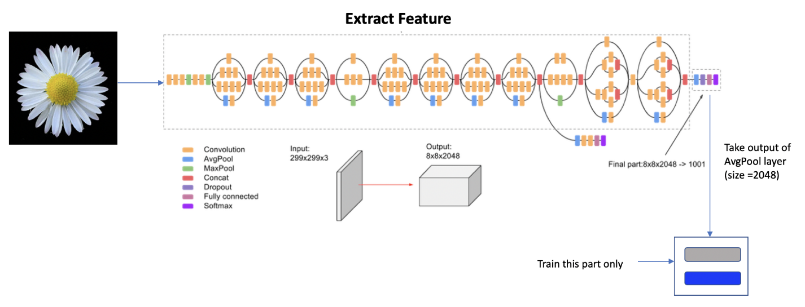
Figure 8: Inception V3 Transfer Learning Model

Optionally loads weights pre-trained on ImageNet. [18] Note that the data format convention used by the model is the one specified in the tf.keras.backend.image_data_format().
Note: each Keras Application expects a specific kind of input preprocessing. For InceptionV3, call tf. keras. applications. inception_v3. preprocess input on your inputs before passing them to the model. [17]
Arguments:
- include top: Boolean, whether to include the fully-connected layer at the top, as the last layer of the network. Default to True.
- weights: One of None (random initialization), ImageNet (pre-training on ImageNet), or the path to the weights file to be loaded. Default to ImageNet.
- input tensor: Optional Keras tensor (i.e., output of layers. Input ()) to use as image input for the model. input tensor is useful for sharing inputs between multiple different networks. Default to None.
- input shape: Optional shape tuple, only to be specified if include top is False (otherwise the input shape has to be (299, 299, 3) (with channels last data format) or (3, 299, 299) (with channels first data format). It should have exactly 3 inputs channels, and width and height should be no smaller than 75. E.g. (150, 150, 3) would be one valid value. input shape will be ignored if the input tensor is provided.
- pooling: Optional pooling mode for feature extraction when include top is False.
  - None (default) means that the output of the model will be the 4D tensor output of the last convolutional block.
  - avg means that global average pooling will be applied to the output of the last convolutional block, and thus the output of the model will be a 2D tensor.
  - max means that global max pooling will be applied.
- classes: optional number of classes to classify images into, only to be specified if include top is True, and if no weights argument is specified. Default to 1000.
- classifier activation: A str or callable. The activation function to use on the "top" layer. Ignored unless include top=True. Set classifier activation=None to return the logits of the "top" layer. [20]
Returns:
A keras Model instance.
Raises
- Value Error: in case of invalid argument for weights, or invalid input shape.
- Value Error: if classifier activation is not SoftMax or None when using a pretrained top layer.

Chapter 4
Experimental Setup

4.1 Hardware Requirement:
This whole process doesn’t need a lot of hardware. We just need to capture the images then process those. For capturing the OCT images, we need to use a hardware named OCT Machine / Optical Coherence Tomography Machine. OCT Machine is a non-invasive imaging evaluation and useful in diagnosing many eye problems. OCT uses light waves to take images of your retina. With OCT, your ophthalmologist can view each of the retina's distinctive layers. OCT uses rays of light to measure retinal thickness. No radiation or X-rays are used in this test, an OCT scan does not hurt and it is not uncomfortable.
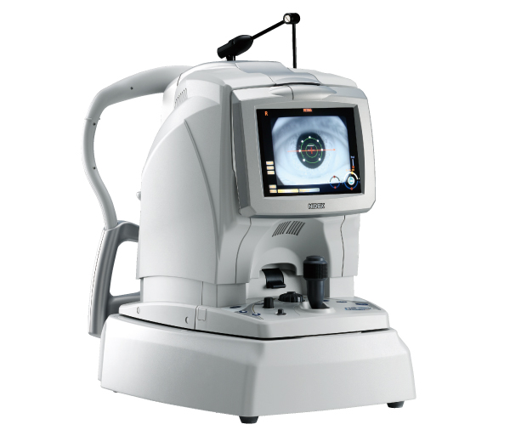

–––

––

Figure 9: OCT Machine

4.2 Software Requirement:

This whole process is mainly based on the Software works. After getting the images from the OCT Machine, it’s all about the software works. In previous chapters, we’ve already mentioned that our main tool will be Python.

Some basic requirements are given below:
- Anaconda Environment
- Jupyter Notebook

Anaconda Environment: In Anaconda Environment, all new environments created with conda automatically include Python, Jupyter Notebooks and pip. You can specify any other packages you want included in your new environment. By default, conda creates a new environment in the project’s env directory—so that all team members have access to the environment. Anaconda provide conda command for you to do a lot of common tasks such as install / uninstall packages, create / remove isolated python environment etc. Isolated python environment is very useful when you develop Python application for different Python version. For example, if you want to run the Python app on both Python 2.7 and Python 3.6, then you need to test the app on both the two Python version.



Figure 10: Anaconda Environment

Chapter 5
Result and Discussion

5.1 Performance Evaluation
As this thesis is all about evaluating the impact of Denoising OCT images for classification, there is going to be two repeated process.
- Classification with noisy image dataset
- Classification with denoised image dataset

Classification with Noisy Image Dataset:
In this step after completing the testing, we got the accuracy of 95.226%
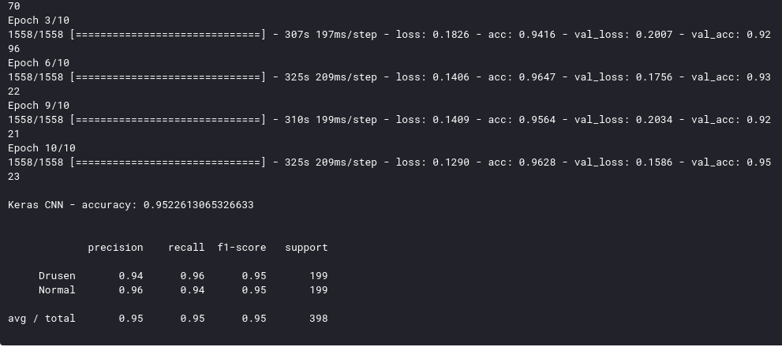
Figure 11 : Accuracy of classification with noisy image dataset

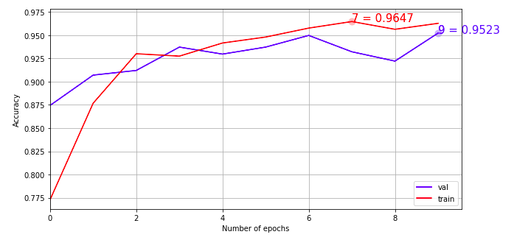

Figure 12: Training and validation accuracy curve on the basis of number of epochs

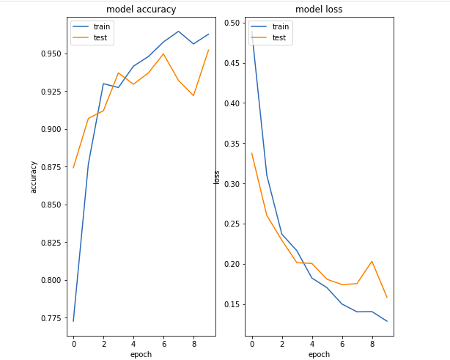

Figure 13: Model accuracy and model loss curve

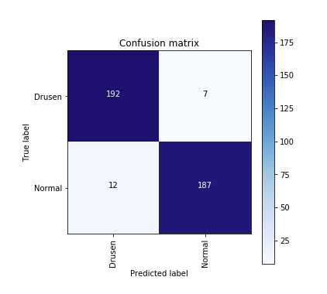

Figure 14: Confusion Matrix for noisy image dataset classification

Classification with Denoised Image Dataset:
In this step after completing the testing, we got the accuracy of 95.70%

Figure 15: Accuracy of classification with denoised image dataset
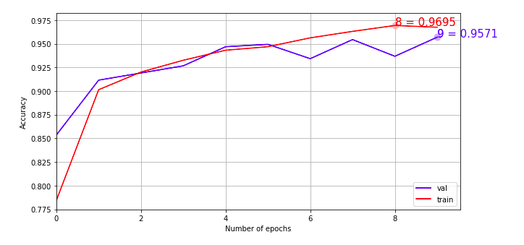
Figure 16: Training and validation accuracy curve on the basis of number of epochs
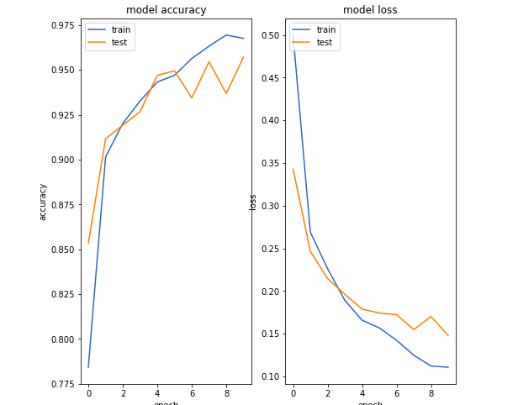

Figure 17: Model accuracy and model loss curve

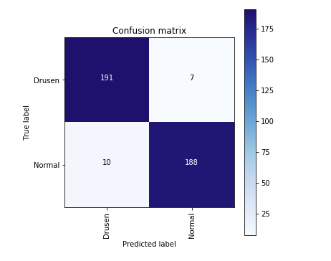

Figure 18: Confusion Matrix for noisy image dataset classification

5.2 Comparative Study

 | Noisy Image Dataset | Denoised Image Dataset
No of Images | 2100 | 2100
No of epochs | 10 | 10
Train Accuracy | 0.9647 | 0.9695
Validation Accuracy | 0.9523 | 0.9571

Table 1: Comparison of classification results between Noisy Image Dataset and Denoised Image Dataset

Chapter 6
Conclusion

From the Result and Discussion Chapter we’ve got a clear overview of what can be the impact of Denoising OCT images in terms of Classifying the images. We’ve seen that in the first term, we did the classification with the noisy image dataset and we got the validation accuracy of 95.23%
Then with the dataset of denoised images, we got the accuracy of 95.70%
The number of images, number of epochs, test-train split ratio everything were same but for the second step we used the Denoised version of the noisy image dataset which is giving almost 0.47% more accuracy.

References
[1] Sugmk, J., Kiattisin, S., & Leelasantitham, A. (2014). Automated classification between age-related macular degeneration and Diabetic macular edema in OCT image using image segmentation. The 7th 2014 Biomedical Engineering International Conference.doi:10.1109/bmeicon.2014.7017441
[2] Shang, Z., Fu, Z., Liu, C., Xie, H., & Zhang, Y. (2018). Potential of Attention Mechanism for Classification of Optical Coherence Tomography Images. 2018 IEEE Visual Communications and Image Processing (VCIP). doi:10.1109/vcip.2018.8698622
[3] Rasti, R., Rabbani, H., Mehridehnavi, A., & Hajizadeh, F. (2018). Macular OCT Classification Using a Multi-Scale Convolutional Neural Network Ensemble. IEEE Transactions on Medical Imaging, 37(4), 1024–1034. doi:10.1109/tmi.2017.2780115
[4] Ali, M., & Hadj, B. (2010). Segmentation of oct skin images by classification of speckle statistical parameters. 2010 IEEE International Conference on Image Processing.doi:10.1109/icip.2010.5653019
[5] Kepp, T., Ehrhardt, J., Heinrich, M. P., Huttmann, G., & Handels, H. (2019). Topology-Preserving Shape-Based Regression of Retinal Layers in Oct Image Data Using Convolutional Neural Networks. 2019 IEEE 16th International Symposium on Biomedical Imaging (ISBI 2019). doi:10.1109/isbi.2019.8759261
[6] Perdomo, O., Otalora, S., Gonzalez, F. A., Meriaudeau, F., & Muller, H. (2018). OCT-NET: A convolutional network for automatic classification of normal and diabetic macular edema using sd-oct volumes. 2018 IEEE 15th International Symposium on Biomedical Imaging (ISBI 2018). doi:10.1109/isbi.2018.8363839
[7] Rong, Y., Xiang, D., Zhu, W., Yu, K., Shi, F., Fan, Z., & Chen, X. (2018). Surrogate-assisted Retinal OCT Image Classification Based on Convolutional Neural Networks. IEEE Journal of Biomedical and Health Informatics, 1–1.doi:10.1109/jbhi.2018.2795545
[8] Chan, G. C. Y., Shah, S. A. A., Tang, T. B., Lu, C.-K., Muller, H., & Meriaudeau, F. (2018). Deep Features and Data Reduction for Classification of SD-OCT Images: Application to Diabetic Macular Edema. 2018 International Conference on Intelligent and Advanced System (ICIAS). doi: 10.1109/icias.2018.8540579 national Conference on Signals and Systems (ICSigSys). doi:10.1109/icsigsys.2017.7967044
[9] Awais, M., Muller, H., Tang, T. B., & Meriaudeau, F. (2017). Classification of SD-OCT images using a Deep learning approach. 2017 IEEE International Conference on Signal and Image Processing Applications (ICSIPA). doi:10.1109/icsipa.2017.8120661
[10] Naz, S., Hassan, T., Akram, M. U., & Khan, S. A. (2017). A practical approach to OCT based classification of Diabetic Macular Edema. 2017 International Conference on Signals and Systems (ICSigSys). doi:10.1109/icsigsys.2017.7967044
[11] Alsaih, K., Tang, T., Meriaudeau, F., Lemaitre, G., Rastgoo, M., & Sidibe, D. (2018). Classification of Retinal Cysts on SD-OCT Images Using Stacked Auto-Encoder. 2018 International Conference on Intelligent and Advanced System (ICIAS). doi:10.1109/icias.2018.8540565
[12] Bogunovic, H., Venhuizen, F., Klimscha, S., Apostolopoulos, S., Bab-Hadiashar, A., Bagci, U., … Schmidt-Erfurth, U. (2019). RETOUCH -The Retinal OCT Fluid Detection and Segmentation Benchmark and Challenge. IEEE Transactions on Medical Imaging, 1–1.doi:10.1109/tmi.2019.2901398
[13] Wang, R., Fan, D., Lv, B., Wang, M., Zhou, Q., Lv, C., … Wang, L. (2020). OCT Image Quality Evaluation Based on Deep and Shallow Features Fusion Network. 2020 IEEE 17th International Symposium on Biomedical Imaging (ISBI). doi:10.1109/isbi45749.2020.9098635
[14] Athira, S. C., Roy, R. M., & Aneesh, R. P. (2018). Computerized Detection of Macular Edema Using OCT Images Based on Fractal Texture Analysis. 2018 International CET Conference on Control, Communication, and Computing (IC4). doi:10.1109/cetic4.2018.8530952
[15] Najeeb, S., Sharmile, N., Khan, M. S., Sahin, I., Islam, M. T., & Hassan Bhuiyan, M. I. (2018). Classification of Retinal Diseases from OCT scans using Convolutional Neural Networks. 2018 10th International Conference on Electrical and Computer Engineering (ICECE). doi:10.1109/icece.2018.8636699
[16] Chan, G. C. Y., Muhammad, A., Shah, S. A. A., Tang, T. B., Lu, C.-K., & Meriaudeau, F. (2017). Transfer learning for Diabetic Macular Edema (DME) detection on Optical Coherence Tomography (OCT) images. 2017 IEEE International Conference on Signal and Image Processing Applications (ICSIPA). doi:10.1109/icsipa.2017.8120662
[17] Gan, Y., Yao, X., Chang, E., Amir, S. B., Hibshoosh, H., Feldman, S., & Hendon, C. P. (2016). Comparative study of texture features in OCT images at different scales for human breast tissue classification. 2016 38th Annual International Conference of the IEEE Engineering in Medicine and Biology Society (EMBC). doi:10.1109/embc.2016.7591586
[18] Serener, A., & Serte, S. (2019). Dry and Wet Age-Related Macular Degeneration Classification Using OCT Images and Deep Learning. 2019 Scientific Meeting on Electrical-Electronics & Biomedical Engineering and Computer Science (EBBT). doi:10.1109/ebbt.2019.8741768
[19] Kamble, R. M., Chan, G. C. Y., Perdomo, O., Kokare, M., Gonzalez, F. A., Muller, H., & Meriaudeau, F. (2018). Automated Diabetic Macular Edema (DME) Analysis using Fine Tuning with Inception-Resnet-v2 on OCT Images. 2018 IEEE-EMBS Conference on Biomedical Engineering and Sciences (IECBES). doi:10.1109/iecbes.2018.8626616
[20] Y. Huang and J. Hu, "Residual Neural Network Based Classification of Macular Edema in OCT," 2019 IEEE 31st International Conference on Tools with Artificial Intelligence (ICTAI), Portland, OR, USA, 2019, pp. 736-743, doi: 10.1109/ICTAI.2019.00107.
[21] An, G., Yokota, H., Motozawa, N., Takagi, S., Mandai, M., Kitahata, S., … Akiba, M. (2019). Deep Learning Classification Models Built with Two-step Transfer Learning for Age Related Macular Degeneration Diagnosis. 2019 41st Annual International Conference of the IEEE Engineering in Medicine and Biology Society (EMBC). doi:10.1109/embc.2019.8857468
[22] Abbirame K.S, Padmasini N, Umamaheshwari R IEEE Member andMohamedYacin S, IEEE Member, “Speckle Noise Reduction in Spectral Domain OpticalCoherence Tomography Retinal ImagesUsing Fuzzification Method”, pp 1-6,2014
[23] Ahmadreza Baghaie, Roshan M. D’souza, Zeyun Yu,“SPARSE ANDLOW RANK DECOMPOSITION BASED BATCH IMAGE ALIGNMENT FOR SPECKLEREDUCTION OF RETINAL OCT IMAGES”, pp 226-230,2015
[24] Jun Cheng, Dacheng Tao, Ying Quan, Damon Wing Kee Wong, Gemmy ChuiMing Cheung, Masahiro Akiba and Jiang Liu, “Speckle Reduction in 3D OpticalCoherence Tomography of Retina by A-Scan Reconstruction”, pp 1-10, 2016
[25] Jun Cheng, Yitian Zhao, Yan Hu, Jiang Liu, “PIXEL RECONSTRUCTION FORSPECKLE REDUCTION IN 3D OPTICAL COHERENCE TOMOGRAPHY OF RETINA”, pp1424-1427,2019
[26] Wenliang Du, Xiaolin Tian, Yankui SUN, “A Dynamic ThresholdEdge-preservingSmoothing Segmentation Algorithm for Anterior Chamber OCTImages Based on Modified Histogram”, 2011
[27] James Glenn-Anderson PhD, Ying Sonia Yu PhD, “An OptimalSpatiotemporalNoise Filter for NI/OCT Imaging”, pp 1247-1251, 2019
[28] Juan J. Gómez-Valverde, Juan E. Ortuño, Pedro Guerra, BorisHermann, Behrooz Zabihian, José L. Rubio-Guivernau, AndrésSantos, Wolfgang Drexler, María J. Ledesma-Carbayo,EVALUATIONOF SPECKLE REDUCTION WITH DENOISING FILTERING IN OPTICAL COHERENCETOMOGRAPHY FOR DERMATOLOGY”, pp 494 -497,2015
[29] Vikas Gupta, Chi Chiu Chan, Chueh-Loo Poh,Tzu Hao Chow, TayChia Meng, Ng Beng Koon, “COMPUTERIZED AUTOMATION OF WAVELETBASED DENOISING METHOD TO REDUCESPECKLE NOISE IN OCT IMAGES”, pp120 –123,2008
[30] Pradeep K. Gupta, Shyam Lal, Farooq Husain, “Performance Analysis ofDE specklingfilters for Retinal Optical Coherence Tomography Images”, pp 181 –186, 2018
[31] Zhao Hongwei, Lian Baowang, Feng Juan, “Adaptive WaveletTransformation for Speckle Reduction in Optical Coherence TomographyImages”, 2011
[32] Sahar Jorjandi, Hossein Rabbani, Zahra Amini, Raheleh Kafieh, “OCTImage DenoisingBased on Asymmetric Normal Laplace Mixture Model”, pp2679 –2682, 2019
[33] Jun Cheng, Lixin Duan, Damon Wing Kee Wong, Masahiro Akibaand JiangLiu, “Speckle Reduction in Optical Coherence Tomography by Matrix Completionusing Bilateral Random Projection”, pp 186 –189, 2014
[34] Pramod M. Kanjalkar, Divya H. Lokhande, M. Venu Gopal Rao, “Despeckling of Medical OCT Image with Wavelet Based Modified Dual FoldTechnique”, pp 1395 –1400, 2017

